**SOFTWARE REQUIREMENTS SPECIFICATION**

**DOCUMENTATION FOR ONLINE SHOPPING MART**

Name : VIGNESH RG

**ABSTRACT**

**Software Requirements Specification outlines the essential features and functionalities required for the development of an Online Shopping Mart. This aims to provide users with a seamless and convenient shopping experience through features such as user registration, product browsing, secure checkout, order management, and an administrative panel. The document details the system's scope, functional requirements including user, product, shopping cart, checkout, order management, and admin modules, as well as non-functional requirements like performance, security, usability, and reliability. Additionally, constraints such as compatibility and data protection regulations are addressed. This SRS document serves as a comprehensive guide for developers to ensure the successful implementation of the Online Shopping Mart.**

**Introduction**

The Online Shopping Mart Software Requirements Specification (SRS) outlines the requirements for the development of an online shopping platform. This document provides a detailed description of the functionalities, features, and constraints of the system.

The purpose of the Online Shopping Mart is to provide a convenient and user-friendly platform for users to browse, search, and purchase products online. The system aims to streamline the shopping experience by offering a wide range of products, secure payment methods, and efficient order management.

**SYSTEM REQUIREMENTS**

**Functional Requirements**

**User Module** : Users can register with the system by providing necessary information such as name, email, and password.

**Product Module**: Users can browse products by category or search for specific products, with detailed information such as name, description, price, and images.

**Shopping Cart Module**: Users can add products to their shopping cart with the option to select quantity.

**Checkout Module**: Users can securely checkout with encryption for sensitive information and multiple payment options.

**Order Management Module**: Users can track the status of their orders and view order history.

**Non-Functional Requirements**

**Performance:** The system should handle a large number of concurrent users efficiently.

**Security**: Implementation of secure authentication and authorization mechanisms to protect user data.

**Usability:** The platform should have an intuitive and user-friendly interface for easy navigation.

**Reliability**:The system should be reliable and available all the time with minimal downtime for maintenance.

**MODULAR DESCRIPTION**

User Module : Users can register with the system by providing necessary information such as name, email, and password.

Product Module: Users can browse products by category or search for specific products, with detailed information such as name, description, price, and images.

Shopping Cart Module: Users can add products to their shopping cart with the option to select quantity.

Checkout Module: Users can securely checkout with encryption for sensitive information and multiple payment options.

Order Management Module: Users can track the status of their orders and view order history.

**SYSTEM ARCHITECTURE**

**FLOW CHART**

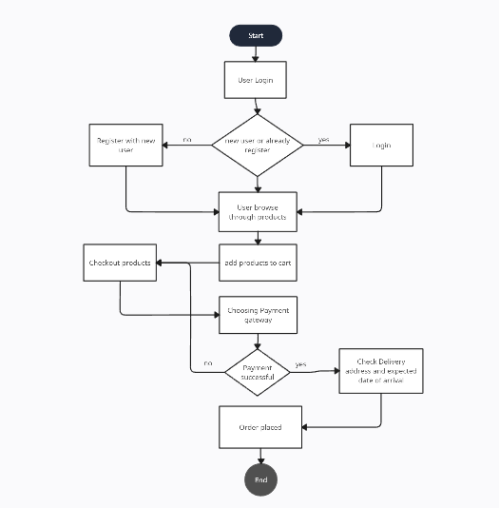

**CLASS DIAGRAM**

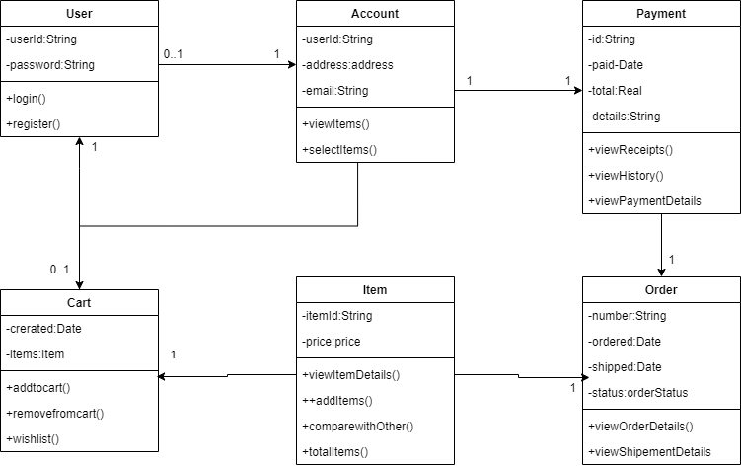

**SEQUENCE DIAGRAM**

# 